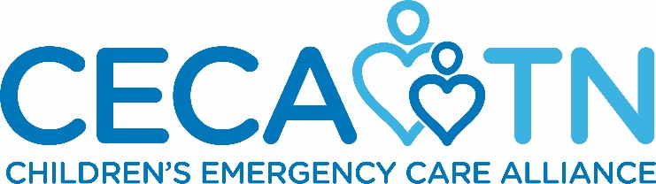

10th Annual EMS Star of Life
Awards Dinner and Ceremony

May 16, 2018
Rocketown
601 4th Avenue South
Nashville, TN 37210

Name of Company: __________________________________________________________
Address: _____________________________________________________________________
Contact Person: _________________________________________________________
Contact Number(s):___________________________________________
E-mail Address: _________________________________________________________
Name(s) of company representatives that will attend Star of Life Awards Dinner
(Reference sponsorship description to find out number of people included in sponsorship level):
____________________________________________________________________________________________________________________________________________________________
Sponsor Level (circle one):
$5,000 Star Partner Level $2,500 North Star Level $1,500 Gold Star Level
$1,000 Silver Star Level $500 Bronze Star Level
Please make checks payable to:
Children’s Emergency Care Alliance
Formerly
Tennessee Emergency Medical Services for Children Foundation

Please Remit Checks to:
3841 Green Hills Village Drive, Suite 3045
Nashville, Tennessee 37215

*Preference of payment by check, thank you!

Deadline for Sponsorship is May 4, 2018
Thanks you for supporting our efforts to honor and recognize the state of Tennessee’s exceptional EMS Providers! Your sponsorship will help us provide an event designed to publicize the value of our prehospital delivery systems.
If you have any questions, please feel free to contact Rhonda Phillippi, 6153433672, Rhonda.phillippi@vumc.org

