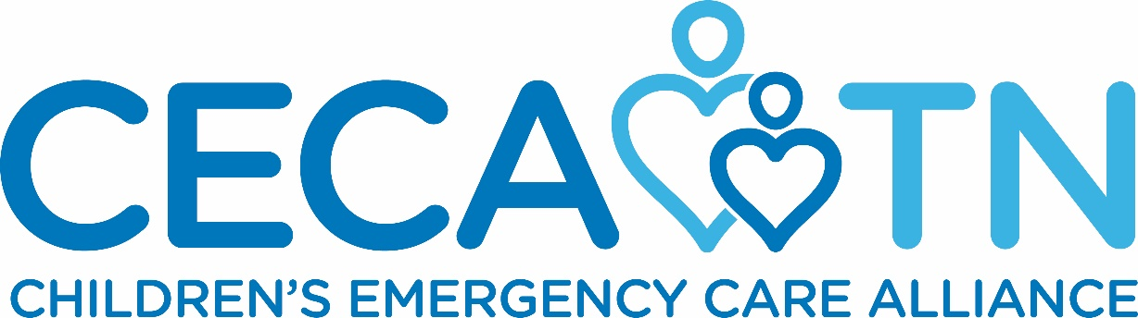

Formerly TN Emergency Medical Services for Services
Proudly Presents

The 11th Annual Star of Life
Awards Dinner & Ceremony
May 15, 2019
Rocketown
601 4th Avenue South
Nashville, TN 37210

What is the EMS Star of Life?

Who is prepared to save a life and provide comfort during life’s scariest, and at times tragic, moments? How often are these everyday heroes recognized? Are they ever celebrated? The Star of Life Awards honor the accomplishments of EMS personnel from all regions of Tennessee who provide exemplary life-saving care to adult and pediatric patients. The goal of the award is to recognize exceptional front-line care, with a focus on agencies and providers who are the initial responders. Each year the ceremony includes a presentation of the patient scenarios and reunites the EMS caregivers with the individuals they treated. This is the premier event in Tennessee to recognize and honor our excellent prehospital providers.

Sponsor the Star of Life Awards!

You are invited to participate in this prestigious dinner and ceremony as a sponsor. Because it is our goal to offer this as a free event to EMS personnel and their families who wish to attend, we are offering the opportunity for financial sponsorship. Contributing to the Star of Life Awards honors the individuals and organizations who exemplify Tennessee’s emergency medical services system’s commitment to emergency care. The Star of Life Awards:

- Reunite EMS providers with the person treated and highlight the actual patient scenario.
- Honor exceptional EMS personnel from each of Tennessee’s eight EMS Regions.
- Recognize Tennessee’s EMS systems and organizations.
- Educate the public and policy makers about the significant role of EMS in the healthcare system.
- Generate positive media stories regarding prehospital care and the EMS Star of Life Award.
- Magnify the profile of National EMS Week in the state of Tennessee.

Sponsorship & Support Opportunities

Star Partner $5,000
Exclusive benefits include:
- Includes Table/Seating for 10 at Star of Life Awards
- Program Recognition: Full Page Black & White Ad and Company Logo
- Media release recognition
- Star Partner Recognition on Stage
- Signage in Event Recognizing Program Support
- Placard

The North Star $2,500
Exclusive benefits include:
- Includes Table/Seating for 10 at Star of Life Awards
- Program Recognition: 1/2 Page Black & White Ad and Company Logo
- Placard

Gold Level $1,500
Exclusive benefits include:
- Includes Seating for 4 at Star of Life Awards
- Program Recognition and Placard

Silver Level $1,000
Exclusive silver level benefits include:
- Includes Seating for 2 at Star of Life Awards
- Program Recognition and Placard

Bronze Level $500
Exclusive bronze level benefits include:
- Program Recognition

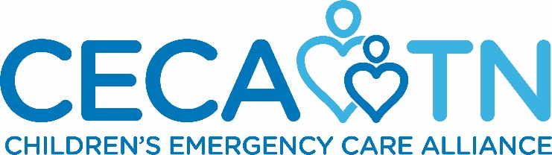

11th Annual EMS Star of Life
Awards Dinner and Ceremony

May 15, 2019
Rocketown
601 4th Avenue South
Nashville, TN 37210

Name of Company: __________________________________________________________
Address: _____________________________________________________________________
Contact Person: _________________________________________________________
Contact Number(s):___________________________________________
E-mail Address: _________________________________________________________
Name(s) of company representatives that will attend Star of Life Awards Dinner
(Reference sponsorship description to find out number of people included in sponsorship level):
__________________________________________________________________________________________
Sponsor Level (circle one):
$5,000 Star Partner Level $2,500 North Star Level $1,500 Gold Star Level
$1,000 Silver Star Level $500 Bronze Star Level
Please make checks payable to:
Children’s Emergency Care Alliance
Formerly
Tennessee Emergency Medical Services for Children Foundation

Please Remit Checks to:
3841 Green Hills Village Drive, Suite 3048
Nashville, Tennessee 37215

*Preference of payment by check, thank you!

Deadline for Sponsorship is May 4, 2019
Thanks you for supporting our efforts to honor and recognize the state of Tennessee’s exceptional EMS Providers! Your sponsorship will help us provide an event designed to publicize the value of our prehospital delivery systems.
If you have any questions, please feel free to contact Marisa Moyers at at marisa.moyers@erlanger.org or 423-778.7262

