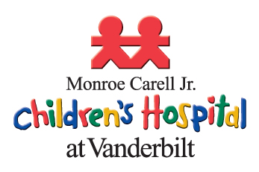
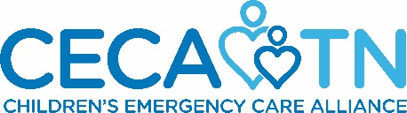
Greetings from Monroe Carell Jr. Children’s Hospital at Vanderbilt and Children’s Emergency Care Alliance. We are contacting you with an invitation to become a Table Host at “Music is Medicine.”

The event is a casual evening of support for these organizations which includes entertainment, auction and other fun surprises – all to benefit children of Tennessee. The event is open to the public, is set for
Thursday, April 2, 2020 at The Barn at Sycamore Farms, and is becoming a “must-do” event for our community.

What does a Table Host do?
- Lend your name to our event promotions as a Table Host.
- Attend the event occurring at The Barn at Sycamore Farms on Thursday, April 2, 2020.
- Recruit 10 people (individuals or couples or a combination of both) to the event by asking them to purchase tickets.
  - Hosts may pay for their guests or ask guests to purchase their own tickets ($75/person).
  - Ticket sales are available online at https://cecatn.org/annual-fundraiser/
- Return the form below to the Friends office to confirm your involvement by January 6, 2020. Forms may be emailed to: cecatn@vumc.org or mailed to:
CECA, 3841 Green Hills Village Drive, Suite 3048, Nashville, TN 37215
- Submit invitee contact information to Children’s Emergency Care Alliance office by February 24, 2020.
  - Send an excel spreadsheet of your invitees to: cecatn@vumc.org.
  - Including: Name, address, e-mail (as we will send a postcard invitation and several eblasts with links to sign up online).

Yes, I/we would be glad to become a Table Host for “Music is Medicine” on April 2, 2020.
Name: ____________________________________________________________________________
Address: ____________________________________________________________________________
Email: ____________________________________________________________________________
Additional Email: ____________________________________________________________________________
*Name for invitation list: ____________________________________________________________________________
*If different from above (ex. Lynn & Scott Ghertner)

We are grateful to your interest in supporting Monroe Carell Jr. Children’s Hospital at Vanderbilt and Children’s Emergency Care Alliance in this fashion.

Best,
Dr. Alex Diamond, Chair for Annual Pediatrics Conference Fundraiser
Dr. Regan Williams, President, Children’s Emergency Care Alliance
Kate Copeland, Administrative Director of Emergency Services, Monroe Carell Jr. Children’s Hospital at Vanderbilt

