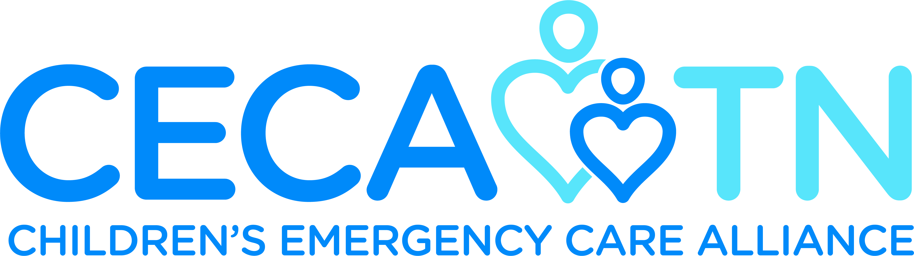

Proudly Presents
The 15th Annual EMS Star of Life
Awards Dinner & Ceremony



Nashville, TN
May 2023

What is the EMS Star of Life?
Who is prepared to save a life and provide comfort during life’s scariest, and at times tragic, moments? How often are these everyday heroes recognized? Are they ever celebrated? The EMS Star of Life event is designed to honor the accomplishments of EMS personnel from all regions of Tennessee who provide exemplary life-saving care to adult and pediatric patients.

The goal is to recognize exceptional front-line care, with a focus on the agencies and providers who are the initial care responders. The ceremony includes a presentation of the actual patient scenarios and reunites the EMS caregivers with the individuals they treated. Recipients will be chosen from each of the eight (8) EMS regions in the state. This is the premier event to recognize and honor our excellent pre-hospital providers, while also celebrating “EMS Week” within Tennessee.

Nominate an EMS provider!
If you know a rescue or medical team that merits consideration as the regional recipient of the EMS Star of Life Award, please complete the Nomination Packet that follows and return it to the Children’s Emergency Care Alliance office via email: cecatn@vumc.org by January 06, 2023.

The Star of Life Awards
- HONOR Exceptional EMS personnel from each of Tennessee’s eight EMS regions
- RECOGNIZE Tennessee’s emergency medical services systems and organizations
- REUNITE EMS providers with the person treated and highlight the actual patient scenario
- GENERATE Positive media stories regarding pre-hospital care and the EMS Star of Life Award
- MAGNIFY The profile of National EMS Week in the state of Tennessee

The Star of Life (SOL) Awards Committee
Reviews nominations and selects winners from each region based on the EMS provider’s service to his/her community and commitment to saving the lives of his/her patients. To ensure that all qualified EMS providers are considered, we are asking for nominations for recipients of this prestigious EMS Star of Life Award.

Nomination Qualifications
- The patient encounter must have occurred during the calendar year of 2022
- The patient can be of any age – adult or pediatric
- The patient had a return to neurological baseline
- Standards of care (protocols) are followed
- The patient EMS run sheets and aeromedical documentation (if applicable) will be submitted and reviewed for completeness
- All requested information must be submitted for the nomination packet to be considered by the SOL Committee

Note
A nomination will be disqualified from receiving the Star of Life Award if the nominated crew has been recognized for this call in a prior ceremony.

Star of Life Awards Dinner & Ceremony

If you know EMS providers who merit consideration as the regional recipient of the EMS Star of Life Award, please complete the forms enclosed with this packet.

Our desire is to have the patient reunited with the EMS providers at the ceremony, so please discuss this with the patient and encourage them to attend with their family. Once all nominations are reviewed, the EMS Star of Life Awards Committee will notify you if your EMS personnel have been chosen.

Social Media - Follow Us on Social Media!
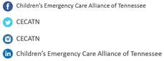

Photos of Patients and Responders
We will need photos of the patient(s) and all responders involved as part of their care team (to include names of people pictured). Photos are used in the Award Ceremony, PowerPoint presentation shown during the ceremony and printed in the Awards Program, which is provided for everyone in attendance. It’s extremely important for names listed to be spelled correctly and verified. A photo taken from a cell phone is perfectly acceptable and these may be emailed with the packet.

Everyone who submits a nomination packet for their Region will be contacted by the CECA Office to let them know if their Region was an Award Recipient. We desire to recognize all EMS Services that will be nominated from all Regions across Tennessee on stage at the 2023 Star of Life Event. Please make plans to attend.

Thank you for supporting our efforts to honor and recognize the state of Tennessee’s exceptional EMS providers! If you have any questions, feel free to contact Natasha Kurth via email: cecatn@vumc.org, or call 615-343-3672.

Sincerely, Sincerely,

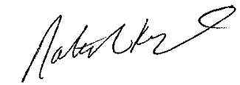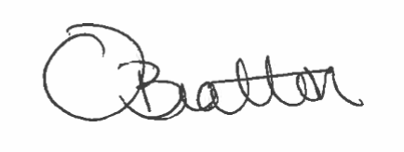

Natasha Kurth, MBA, MHA Oseana Bratton, BSN, RN, CPEN, CHEP
Executive Director President, CECA TN &
Children’s Emergency Care Alliance CRPC Coordinator East TN Children’s Hospital
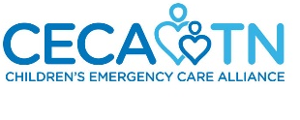


DEADLINE FOR SUBMISSION - January 6, 2023
Submit Your Nomination to the Children’s Emergency Care Alliance office: cecatn@vumc.org

Contact Us with Questions

Natasha Kurth, MBA, MHA Jennifer Powell
Executive Director Sr. Administrative Assistant 615-343-3672 615-875-4397
Children’s Emergency Care Alliance
615-343-3672
cecatn@vumc.org

Checklist for Nomination Submission (Disqualification will occur if requested documents/pictures are not received)

___ Patient(s) Consent Form
(It is a HIPAA violation to send patient medical records without their permission. Please allow enough time to secure the patient’s signature).

___ Typed Official Star of Life Awards Nomination Form

___ Typed Information Sheet Listing Members of Every Organization Involved in Incident (included with this packet). Names Verified and Spelled Correctly, along with Email addresses. Star of Life Invitations will be sent to all email addresses provided. Also, please include notable officials (Mayor, Senator, State Representative) from your Region who should receive a Star of Life Invitation to the event.

___ Copy of Run Sheet (and Aeromedical sheet, if applicable).

___ News Articles and pertinent team/individual photos of incident, if applicable.

___ Responder Team Photos and Patient Photos listing names of people pictured for all responders involved in care of the patient(s) and each patient pictured. Example: First Responders, Air Medical, Police and Dispatchers. It is the nomination person’s responsibility to obtain photos and send them along with the nomination packet to the CECA office as an attachment via email: cecatn@vumc.org. Photos from cell phones are perfectly acceptable, as long as they are a minimum of 300 DPI.

___ Granite Stone Award Engraving Form

___ Media Form

Photos from the 2022 Star of Life Awards are located on our FaceBook Page (Like us)!

https://www.facebook.com/pg/Childrens-Emergency-Care-Alliance-of-Tennessee-204808666822582/photos/?tab=album&album_id=359715551331892

Star of Life NOMINATION FORM
Patient Information (PRINT)

EMS Region: _____
Patient’s Name:

Mailing Address:

City, State, Zip:

Cell Phone: Email:

Patient’s Diagnosis:

Date of Incident: Place of Incident:

Patient’s Name:

Mailing Address:

City, State, Zip:

Cell Phone: Email:

Patient’s Diagnosis:

Date of Incident: Place of Incident:

Patient Consent Form attached. Your submission will be incomplete until the consent form is signed by the patient(s) and included with this packet.

Person Completing the SOL Nomination Packet for their Region

Name: Title:

Organization:

Address:

City, State & Zip:

Cell Phone: Email:

It is your responsibility to provide all information requested in this packet. We understand it may take a while to gather, but it is greatly appreciated and needed! We use information from this packet to have the Granite Stone Awards engraved, create the PowerPoint presentation shown during the Dinner & Awards Banquet and print the Award Certificates handed out on stage. The photos submitted are used in printed materials and posted on various social media platforms, as well as printed in the Awards Banquet & Dinner Program provided at each table seating at the event. We rely on the accuracy of the information submitted by you to eliminate the need for re-printing of Award Certificates due to names being misspelled, or people involved in the care of the patients omitted. We would like you to serve as the point person to help us distribute any unclaimed Award Lapel Pins and Certificates at the end of the Star of Life ceremony, (or a person you designate in your stead), if you are unable to attend the event. Thank you for your time and meticulous attention to detail when completing this packet. We could not gather all the necessary Award information for all Regions across Tennessee without your help! Thank you in advance for your willingness to support and honor your Region.
Notes:

NARRATIVE OF INCIDENT (Please TYPE)
In your own words, please provide a written narrative of the EMS run and attach a copy of the all EMS run sheets, aeromedical run sheets (if applicable), and emergency department notes.

WHY SHOULD THIS REGION RECEIVE THE STAR OF LIFE AWARD?

In your own words, please explain why you think the EMS Star of Life Award should be given to the nominees?

Patient(s) Consent & Release of Protected Medical Information
Patient Name (PRINT):
Permission is hereby granted to Children’s Emergency Care Alliance to utilize the information contained in the EMS run report for my care that occurred on the _____ day of __________ (month), ______ (year), in _______________, Tennessee.
I understand that the EMS run report contains personal medical information that may, under state and federal laws, be considered confidential, and I hereby expressly waive my right to maintain the confidentiality of this medical information, so that the information in the EMS run report may be used by Tennessee Emergency Medical Services for Children Foundation in connection with the EMS Star of Life Award Ceremony. This release and waiver include the potential publication of the information on television, radio and print media.
I also expressly waive any and all claims that I might have against the EMS service that prepared the EMS run report and/or against Tennessee Emergency Medical Services for Children Foundation, in connection with the use of this information for the EMS Star of Life Award Ceremony.
________________________________ ________________________________
Patient Signature Witness

________________________________ ________________________________
Date Date

Do you plan to attend the EMS Star of Life Awards Dinner & Ceremony with your Family?
(Selection will not be based on attendance)

- Yes
- No

GRANITE STONE AWARD - ENGRAVING FORM


Agency Names to be Engraved on the Granite Stone Award
(Please TYPE & VERIFY How Each Agency Wants to be Listed).
*OPTIONAL for submission – will need this information within two weeks of being selected as your region’s winner.

______________________________________ _____________________
Name & Signature of Person Completing Form Date

MEDIA FORM

Please list Media Contacts (TV, Newspaper, Radio, etc.) you would like the CECA TN office to contact to share with them the Star of Life Awards & Dinner Event for news releases. *OPTIONAL for submission - will need this information if selected as your region's winner

Name | Address | Email | Phone

REGION: _______
All Names and E-mail Addresses Verified and Spelled Correctly? YES: _______
The information provided on this form and pictures submitted are used for the team’s Award Certificates given on stage, for a Power Point presentation shown during the Awards Dinner and printed in the Star of Life Program provided at each table seating. Email addresses are used to send the Star of life Invitation to each person below. Also, please include notable officials (Mayor, Senator, State Representative) who should receive a Star of Life Invitation.
STAR OF LIFE
Individuals Involved From Dispatch To Hospital Doors (All Pre-Hospital Providers)
INFORMATION SHEET
(*OPTIONAL for submission – will need this information within two weeks of being selected as your region’s winner.)
Agency | First Name | Last Name | E-mail | Cell phone

REGION: _______
All Names and E-mail Addresses Verified and Spelled Correctly YES: _______
The information provided on this form and pictures submitted are used for the team’s Award Certificates given on stage, for a Power Point presentation shown during the Awards Dinner and printed in the Star of Life Program provided at each table seating. Email addresses are used to send a Star of life Invitation to each person below. Also, please include notable officials (Mayor, Senator, State Representative) who should receive a Star of Life Invitation.
STAR OF LIFE
Individuals Involved From Dispatch To Hospital Doors (All Pre-Hospital Providers)
INFORMATION SHEET
(*OPTIONAL for submission – will need this information within two weeks of being selected as your region’s winner.)
Agency | First Name | Last Name | E-mail | Cell phone

CECA TN Staff

Executive Director Administrative Assistant

Natasha Kurth Jennifer Powell

CECA TN, 3841 Green Hills Village Drive, Suite 3048, Nashville, TN 37215
Phone: 615-343-3672

 We continuously strive to improve the Star of Life Award ceremony each year. Please let us know if you have any suggestions or ideas on how we can improve this event.

_____________________________________________________________________

_____________________________________________________________________

_____________________________________________________________________

_____________________________________________________________________

_____________________________________________________________________

_____________________________________________________________________

