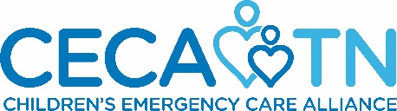 And 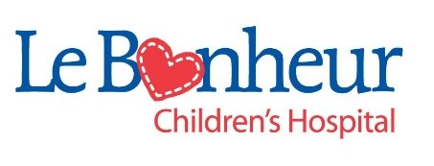

Greetings from Le Bonheur Children’s Hospital and Children’s Emergency Care Alliance. We are contacting you with an invitation to become a Table Host at “Metals, Medicine & Magic in Memphis.”

The event is a casual evening of support for these organizations which includes entertainment, auction and other fun surprises – all to benefit children of Tennessee. The event is open to the public, is set for
Thursday, April 13, 2023 at The Metals Museum, and is becoming a “must-do” event for our community.

What does a Table Host do?
- Lend your name to our event promotions as a Table Host.
- Attend the event occurring at The Metals Museum on Thursday, April 13, 2023.
- Recruit 10 people (individuals or couples or a combination of both) to the event by asking them to purchase tickets.
  - Hosts may pay for their guests or ask guests to purchase their own tickets ($85/person).
  - Ticket sales are available online at https://cecatn.org/annual-fundraiser/
- Return the form below to the CECA office to confirm your involvement by April 3, 2023. Forms may be emailed to: cecatn@vumc.org or mailed to:
CECA, 3841 Green Hills Village Drive, Suite 3048, Nashville, TN 37215
- Submit invitee contact information to Children’s Emergency Care Alliance office by April 7, 2023.
  - Send an excel spreadsheet of your invitees to: cecatn@vumc.org.
  - Including: Name, address, e-mail (as we will send a postcard invitation and several eblasts with links to sign up online).

Yes, I/we would be glad to become a Table Host for “Metals, Medicine & Magic in Memphis” on April 13, 2023.
Name: ____________________________________________________________________________
Address: ____________________________________________________________________________
Email: ____________________________________________________________________________
Additional Email: ____________________________________________________________________________
*Name for invitation list: ____________________________________________________________________________
*If different from above (ex. Lynn & Scott Ghertner)

We are grateful to your interest in supporting Le Bonheur Children’s Hospital and Children’s Emergency Care Alliance in this fashion.

Best,
Dr. Regan Williams, Chair for Annual Pediatrics Conference Fundraiser
Oseana Bratton, President, Children’s Emergency Care Alliance

